[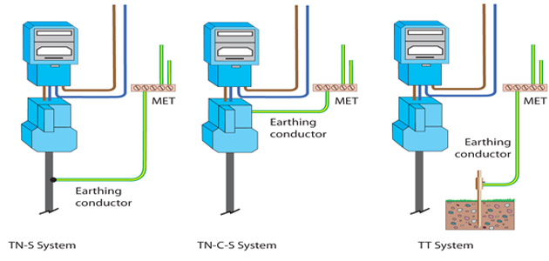](http://www.google.co.uk/url?sa=i&rct=j&q=&esrc=s&source=images&cd=&ved=0ahUKEwir2JmkmOXUAhVJlxoKHV3CAQAQjRwIBw&url=http://www.ultimatehandyman.co.uk/forum1/incoming-mains-earth-t86122.html&psig=AFQjCNFNZRGncLY-ek_ioFwEMwnz3XqB5g&ust=1498898855917968)